**React JS HOL**

**1.React JS HOL -1:**

**Code:**

function App() {

  return (

    <h1>Welcome the first session of React</h1>

  );

}

**Output:**

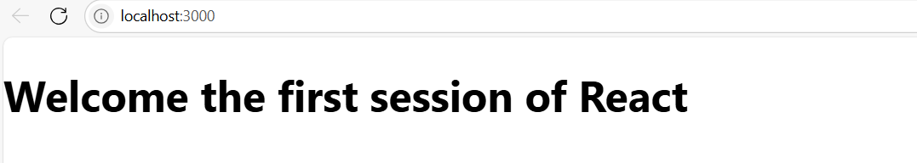

**2.React JS HOL-2:**

**Code:**

import Home from './Component/Home';

import About from './Component/About';

import Contact from './Component/Contact';

function App() {

  return (

    <div>

      <Home />

      <About />

      <Contact />

    </div>

  );

}

export default App;

class Home extends Component {

  render() {

    return (

      <div>

        <h3>Welcome to the Home Page of Student Management Portal</h3>

      </div>

    );

  } }

class About extends Component {

  render() {

    return (

      <div>

        <h3>Welcome to the About Page of Student Management Portal</h3>

      </div>

    );

  }

}

class Contact extends Component {

  render() {

    return (

      <div>

        <h3>Welcome to the Contact Page of Student Management Portal</h3>

      </div>

    );

  }

}

**Output:**

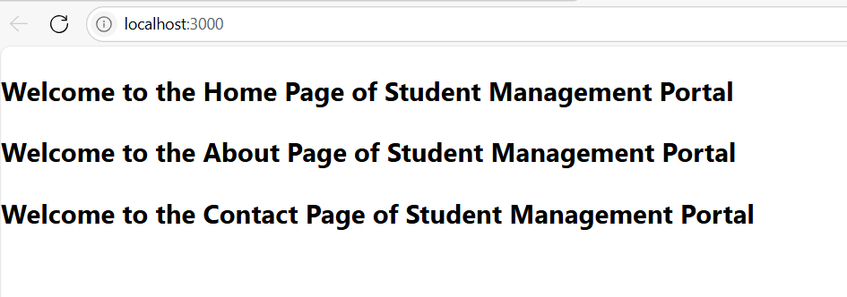

**3.React JS HOL-3:**

**Code:**

import {CalculateScore} from '../src/Component/CalculateScore';

function App() {

  return (

    <div>

      <CalculateScore Name={"Steeve"}

      School={"DNP Public School"}

      total={284}

      goal={3}/>

    </div>

  );

}

export default App;

import '../Stylesheets/mystyle.css';

const percentTiDecimal=(decimal)=>{

  return (decimal.toFixed(2)+'%')

}

const calcScore =(total,goal)=>{

  return percentTiDecimal(total/goal)

}

export const CalculateScore = ({ Name, School, total, goal }) => (

  <div className="formatstyle">

    <h1><font color="Brown">Student Details:</font></h1>

    <div className="Name">

      <b><span> Name: </span></b>

      <span>{Name}</span>

    </div>

    <div className="School">

      <b><span> School: </span></b>

      <span>{School}</span>

    </div>

    <div className="Total">

      <b><span>Total:</span></b>

      <span>{total}</span>

      <span> Marks</span>

    </div>

    <div className="Score">

      <b>Score:</b>

      <span>

        {calcScore(

          total,

          goal

        )}

      </span>

    </div>

  </div>

);

.Name {

    font-weight: 300;

    color: blue;

}

.School {

    color: crimson;

}

.Total {

    color: darkmagenta;

}

.formatstyle {

    text-align: center;

    font-size: large;

}

.Score {

    color: forestgreen;

}

**Output:**

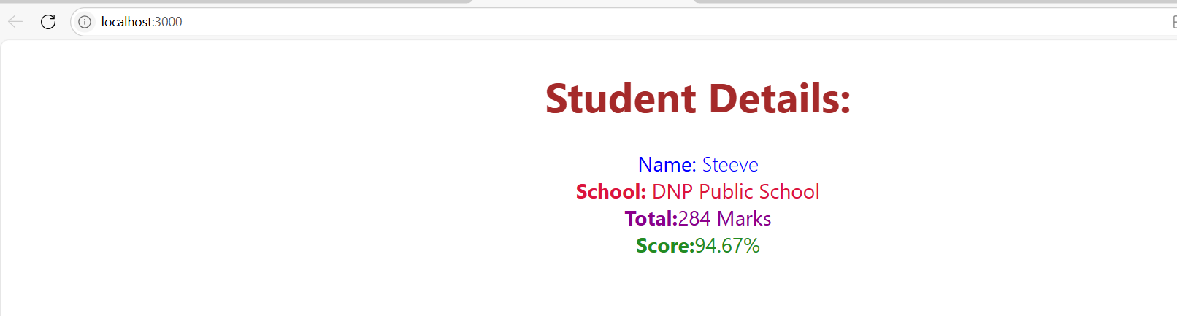

**4.React JS HOL-4:**

**Code:**

import Posts from './Posts';

function App() {

  return (

    <div className='App'>

      <Posts />

    </div>

  );

}

export default App;

const Post=(props)=>{

    return (<div>

    <h3>{props.title}</h3>

    <p>{props.body}</p>

  </div>);

};

export default Post;

import { Component } from "react";

import Post from "./Post";

class Posts extends Component{

    constructor(props){

        super(props);

        this.state={

           posts: [],

           hasError: false

        };

    }

    loadPosts(){

        fetch('https://jsonplaceholder.typicode.com/posts')

      .then((res) => res.json())

      .then((data) => {

        this.setState({ posts: data });

      })

      .catch((err) => {

        this.setState({ hasError: true });

        alert("Error loading posts: " + err.message);

      });

    }

    componentDidMount(){

        this.loadPosts();

    }

    render(){

          return (

      <div>

        <h1>All Posts</h1>

        {this.state.posts.map((post) => (

          <Post key={post.id} title={post.title} body={post.body} />

        ))}

      </div>

    );

    }

    componentDidCatch(error){

         this.setState({ hasError: true });

    alert("Something went wrong: " + error);

    }

}

export default Posts;

**Output:**

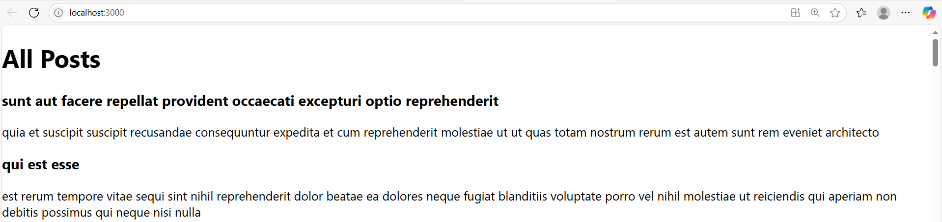

**5.React JS HOL-5:**

**Code:**

.box {

  width: 300px;

  display: inline-block;

  margin: 10px;

  padding: 10px 20px;

  border: 1px solid black;

  border-radius: 10px;

}

dt {

  font-weight: 500;

}

import styles from './CohortDetails.module.css';

function CohortDetails(props) {

  const { cohortName, startDate, endDate, status } = props;

  const headingStyle = {

    color: status === 'ongoing' ? 'green' : 'blue'

  };

  return (

    <div className={styles.box}>

      <h3 style={headingStyle}>{cohortName}</h3>

      <dl>

        <dt>Start Date:</dt>

        <dd>{startDate}</dd>

        <dt>End Date:</dt>

        <dd>{endDate}</dd>

        <dt>Status:</dt>

        <dd>{status}</dd>

      </dl>

    </div>

  );

}

export default CohortDetails;

import CohortDetails from './components/CohortDetails';

function App() {

  const cohorts = [

    {

      name: 'INTADMDF10 - .NET FSD',

      startDate: '22-Feb-2022',

      status: 'Scheduled',

      coach: 'Aathma',

      trainer: 'Jojo Jose',

    },

    {

      name: 'ADM21JF014 - Java FSD',

      startDate: '10-Sep-2021',

      status: 'Ongoing',

      coach: 'Apoorv',

      trainer: 'Elisa Smith',

    },

    {

      name: 'CDBJF21025 - Java FSD',

      startDate: '24-Dec-2021',

      status: 'Ongoing',

      coach: 'Aathma',

      trainer: 'John Doe',

    },

  ];

  return (

    <div>

      <h2>Cohorts Details</h2>

      {cohorts.map((cohort, index) => (

        <CohortDetails key={index} cohort={cohort} />

      ))}

    </div>

  );

}

export default App;

**Output:**

